

Rent Permission - User Stories & Wireframes

Contents
User Stories- Rent Permission Process 2
1. User Story- Add Rent Permission 2
1.1 Mock-ups 5
2. User Story- Approve/Reject Rent Request 7
2.1 Mock-ups 9
3. User Story- View Request- Department User 11
3.1 Mock-ups 12
4. User Story- View Request- Approved 16
4.1 Mock-ups 17
5. User Story- Resubmit request for rent request 18
5.1 Mock-ups 19
6. User Story- Cancel rent permission request 21
6.1 Mock-ups 22
7. User Story- View Comment 23
7.1 Mock-ups 24
8. User Story- Generate Rent Permission Letter 26
8.1 Mock-ups 27
9. User Story- Generate Payment challan- Rent Permission Charge 28
9.1 Mock-ups 29
10. User Story- SMS/Email Notifications to allottee 30

User Stories- Rent Permission Process

User Story- Add Rent Permission

Sprint | 4
User Story ID | 001
User Story Title | Add Rent Request
Actors | Department user
Story | As a department user, I want to request for rent permission of property to manager level, so that I can generate rent permission letter.
Pre Conditions | - User should have required access rights.
Business Criteria | - There would be only one request per property.  - Unique Request no. would be generated for each rent permission request.  - Once, the request is submitted a notification would be sent to approver for the same.  - Auto notifications will be sent to approver with an interval of 3 days, if a request is in progress for approval for more than 3 days.  - An Email/SMS notification would be sent to allottee along with the request no.  - If a request is submitted to an approver but not actioned its status would be ‘In progress’. Approved and rejected requests would have ‘approved’ and ‘rejected’ status respectively.  - If the request is cancelled by the department user, its status would be ‘cancelled’.  - The request will only be approved if the property is functional and there are no due against it.  - Rent permission is granted if:  i. Upto date dues of authority have been cleared.  ii. Lease deed/Transfer deed/Sale deed as applicable has been executed.
Acceptance Criteria | - User would click on ‘Add Rent Request’ option under Rent Permission menu and get a form which contain following fields:  - RID: drop down, mandatory  - Department: Label  - Allottee Name: Label  - Sector: Label  - Block: Label  - Property Number: Label  - Total Dues: Label  - Functional Status: Label  - Request Date: Date picker, mandatory  - Tenant Name: Text Box, mandatory  - Tenant Project: Text Box, mandatory  - Property Type: Dropdown, mandatory  - Rent Duration: Dropdown, mandatory  - Renting Charge: Text Box, mandatory  - Renting Date: Date picker, mandatory  - Once, user validates the information he would submit request for rent permission to manager level by clicking on ‘Submit Request’ button. User would get a popup to select approver name, user would select desired name and click on ‘Submit’ button.  - Alternatively, user would click on ‘Back’ button to return to rent permission menu without making any changes.  - After successful submission of request, it would be displayed in a grid on rent permission page with following columns:  - Request No  - RID  - Scheme  - Department  - Request Date  - Applicant Name  - Tenant Name  - Status (in progress, cancelled, approved, reject)  - User has an option to search on the rent permission screen. User selects scheme and department from the dropdown available, then clicks on search button to view details as per selection criteria on the grid.  - The options available in “Property Type” dropdown are from Property type table in database.  - The options available in “Rent Duration” dropdown are:  - 5 Years  - 10 Years  - Figures will populate as per table in database
Field level Validation | - Tenant Name: Text, maximum 100 characters  - Tenant Project: Text, maximum 200 characters

Mock-ups

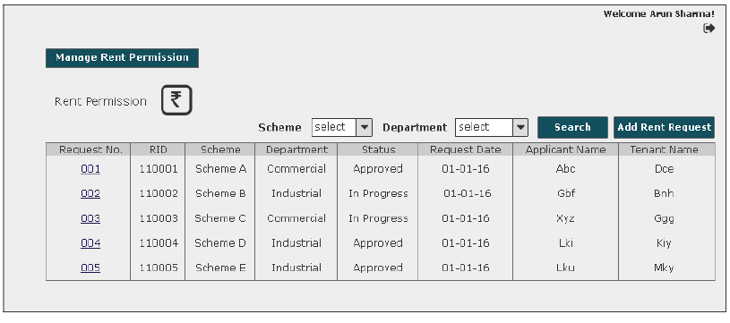
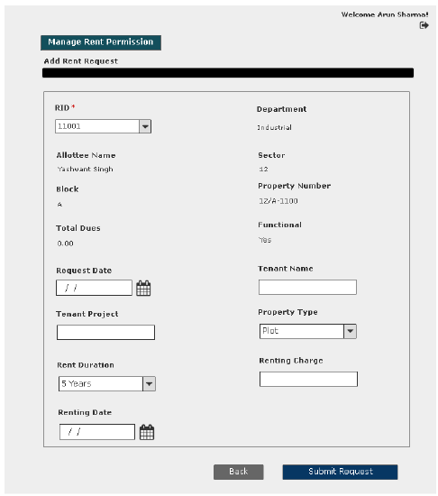
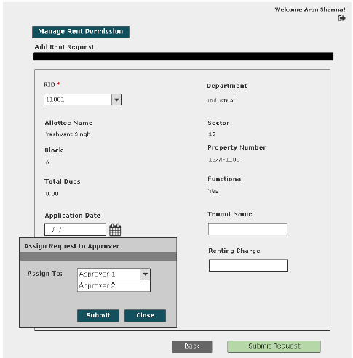

User Story- Approve/Reject Rent Request

Sprint | 4
User Story ID | 001
User Story Title | Approve/Reject rent permission request
Actors | Approver
Story | As an approver, I want to action rent request of a property so that I can Approve/Reject request
Pre Conditions | - User should have required access rights.
Business Criteria | - Once a request is approved/rejected a notification would be send to initiator of the request.  - It is mandatory to provide a comment for rejecting a request.  - If a request is not actioned its status would be ‘No action’. Approved and rejected requests would have ‘approved’ and ‘rejected’ status respectively.  - If the request is cancelled by the department user, its status would be ‘cancelled’. Approver would not get any options to approve, reject.  - The request will only be approved if the property is functional and there are no due against it.  - Rent permission is granted if:  i. Upto date dues of authority have been cleared.  ii. Lease deed/Transfer deed/Sale deed as applicable has been executed.
Acceptance Criteria | - User would click on ‘Rent Requests’ option under ‘Manage Request’ menu and get a grid which contain rent requests information with following columns:  - Request No  - RID  - Scheme  - Department  - Request Date  - Applicant Name  - Tenant Namee  - Status (in progress, cancelled, approved, reject)  - User would click on the request to approve/reject and based on this selection the following information would be displayed:  - RID: drop down  - Department  - Scheme  - Allottee Name  - Property Number  - Total Dues  - Functional Status  - Request Date  - Tenant Name  - Tenant Project  - Rent Duration  - Property Type  - Renting Charge  - Renting Date  - If user finds that the property is functional and there are no pending dues against the property. Then, user would click on ‘Approve’ button to approve the request. Alternatively, would click on ‘Reject’ button to reject the request if conditions are not fulfilled.  - In both cases user would get a popup window to provide comment.  - In case of ‘Approve’ user would have a choice to provide comment or not however, in case of ‘Reject’ it is mandatory to provide comment.  - User has an option to search on the “Manage Request” screen. User selects scheme and department from the dropdown available, then clicks on search button to view details as per selection criteria on the grid.
Field level Validation | - Comment: Text, maximum 500 characters, mandatory in case of reject list.

2.1 Mock-ups

User Story- View Request- Department User

Sprint | 4
User Story ID | 003
User Story Title | View Request
Actors | Department User
Story | As a department user, I want to view submitted rent permission request of a property.
Pre Conditions | - User should have required access rights.
Business Criteria | - If request is submitted but not actioned by the approver then user would get ‘Cancel Request’ option only.  - If the request is rejected by the approver then user would get the option of ‘Resubmit Request’ and ‘View Comment’.  - For cancelled requests user would get the option to ‘resubmit Request’  - If request is approved by the approver then user would get following options:  - Generate Rent Permission Letter  - View Comment
Acceptance Criteria | - User would click on a particular request from the grid under manage request menu.  - User would get a screen which would display the following information:  - RID: drop down  - Department  - Allottee Name  - Sector  - Block  - Property Number  - Total Dues  - Functional Status  - Request Date  - Tenant Name  - Tenant Project  - Property Type  - Rent Duration  - Renting Charge  - Renting Date
Field level Validation

Mock-ups

The cases covered in the Business Rules in context to “Status” are shown in the wireframe. Please refer.
Submitted for approval
Request is submitted but not actioned by the approver

Cancelled/Rejected
Approved

User Story- View Request- Approver

Sprint | 4
User Story ID | 004
User Story Title | View Request
Actors | Approver
Story | As an Approver, I want to view submitted rent request of a property.
Pre Conditions | - User should have required access rights.
Business Criteria | - If the request is not actioned then, user would get ‘Approve’ and ‘Reject’ button.  - If request is cancelled, approved or rejected then user would not get any option.
Acceptance Criteria | - User would click on approved service request number from the grid under Manage Request menu  - User would get a screen which would display the following information:  - RID: drop down  - Department  - Scheme  - Allottee Name  - Property Number  - Total Dues  - Functional Status  - Request Date  - Tenant Name  - Tenant Project  - Rent Duration  - Property Type  - Renting Charge  - Renting Date  - If the request is approved then it would also contain the “Back” Button.
Field level Validation

Mock-ups

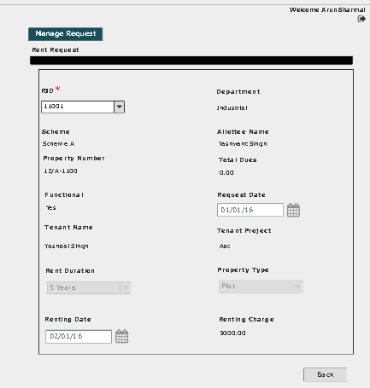

User Story- Resubmit request for rent request

Sprint | 4
User Story ID | 005
User Story Title | Resubmit request for rent permission
Actors | Department User
Story | As a department user, I want to resubmit rent request of a property.
Pre Conditions | - User should have required access rights.
Business Criteria | - Only Cancelled and rejected requests would be resubmitted.  - Requested date would be updated on the grid.
Acceptance Criteria | - User would click on a particular request from the grid under manage rent permission menu.  - Request will be displayed and user would click on the ‘Resubmit’ button to request again.  - Alternatively, user would click on ‘Back’ button to return to the manage rent permission page without making any changes.
Field level Validation

Mock-ups

User Story- Cancel rent permission request

Sprint | 4
User Story ID | 006
User Story Title | Cancel rent permission request
Actors | Department User
Story | As a department user, I want to cancel rent request of a property.
Pre Conditions | - User should have required access rights.
Business Criteria | - Only those request which are in progress would be cancelled.  - The status in the manage rent permission grid would be displayed as “Cancelled”.
Acceptance Criteria | - User would click on a particular request with status “In Progress” from the grid under manage rent permission menu.  - Request will be displayed and user would click on the ‘Cancel Request’ button to cancel the request.  - Alternatively, user would click on ‘Back’ button to return to the manage rent permission page without making any changes.
Field level Validation

Mock-ups

User Story- View Comment (Requestor)

Sprint | 4
User Story ID | 007
User Story Title | View Comment
Actors | Department user
Story | As a department user, I want to view comment on Approve/Rejected rent request
Pre Conditions | - User should have required access rights.
Business Criteria | - Only, approved/rejected request would contain the option to View comment.
Acceptance Criteria | - User would click on ‘View Comment’ button on rent permission screen.  - User would see a Popup window with the following information:  - Comment from  - Comment  - Comment Date  - If user wishes to go back or close this screen, user would click on ‘Back’ button and would be redirected to rent permission screen.

Mock-ups

User Story- View Comment (Approver)

Sprint | 4
User Story ID | 007
User Story Title | View Comment
Actors | Approver
Story | As an approver, I want to view comment on Approve/Rejected mortgage request
Pre Conditions | - User should have required access rights.
Business Criteria | - Only, approved/rejected request would contain the option to View comment.
Acceptance Criteria | - User would click on ‘View Comment’ button on approved/rejected mortgage request screen.  - User would see a Popup window with the following information:  - Comment from  - Comment  - Comment Date  - If user wishes to go back or close this screen, user would click on ‘Back’ button and would be redirected to manage mortgage screen.

Mock-ups

User Story- Generate Rent Permission Letter

Sprint | 4
User Story ID | 008
User Story Title | Generate Rent Permission Letter
Actors | Department user
Story | As a department user, I want to generate rent permission letter.
Pre Conditions | - User should have required access rights.
Business Criteria | - Only, approved request would contain the option to generate rent permission letter.  - System would check for payment of rent permission charge. If not payed then, rent permission letter will not be generated and system would ask the user to pay the charge.
Acceptance Criteria | - User would click on ‘Generate Rent Permission’ button on rent request screen.  - Rent permission letter would be displayed on a separate screen.  - User would have the options to save the file to his local system by clicking on ‘Save’ button or print rent permission letter by clicking on ‘Print’ button.
Field Level Validations

Mock-ups

User Story- Generate Payment challan- Rent Permission Charge
Sprint | 4
User Story ID | 009
User Story Title | Generate Payment challan- Rent Permission Charge
Actors | Department user
Story | As a department user, I want to generate payment challan for rent permission charge.
Pre Conditions | - User should have required access rights.
Business Criteria | - Only, approved request would contain the option to generate payment challan.  - Formula of Rent Permission Charge:  Rent Permission charge = (FAR * Defined Amount) * N  FAR = Floor Area Ratio  Defined Amount = Area-wise amount set by the authority  N = number of years
Acceptance Criteria | - User would click on ‘Payment challan’ button on rent permission request screen.  - Rent charge payment challan would be displayed on a separate screen.  - User would have the options to save the file to his local system by clicking on ‘Save’ button or print payment challan by clicking on ‘Print’ button.
Field Level Validations

Mock-ups

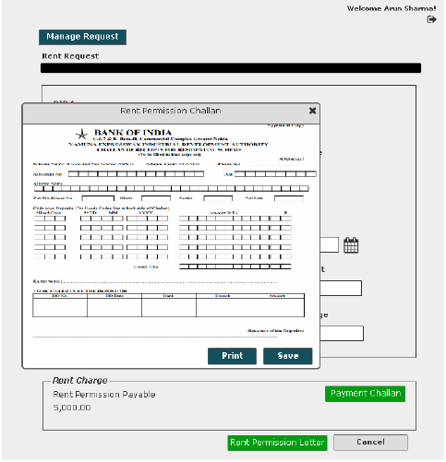

User Story- SMS/Email Notifications to allottee

Sprint | 5
User Story ID | 011
User Story Title | SMS/Email notifications to allottee
Actors | allottee
Story | As an allottee I want system to send me SMS/email notifications for rent permission request
Pre Conditions | - User should have required access rights.
Business Criteria | - An SMS/Email notification would be send to allottee once; the request is submitted for rent permission.  - An SMS/Email notification would be send to allottee once; the request is cancelled.  - An SMS/Email notification would be send to allottee once; the request is rejected with comment.  - An SMS/Email notification would be send to allottee once, the request is approved
Acceptance Criteria
Field Level Validations

